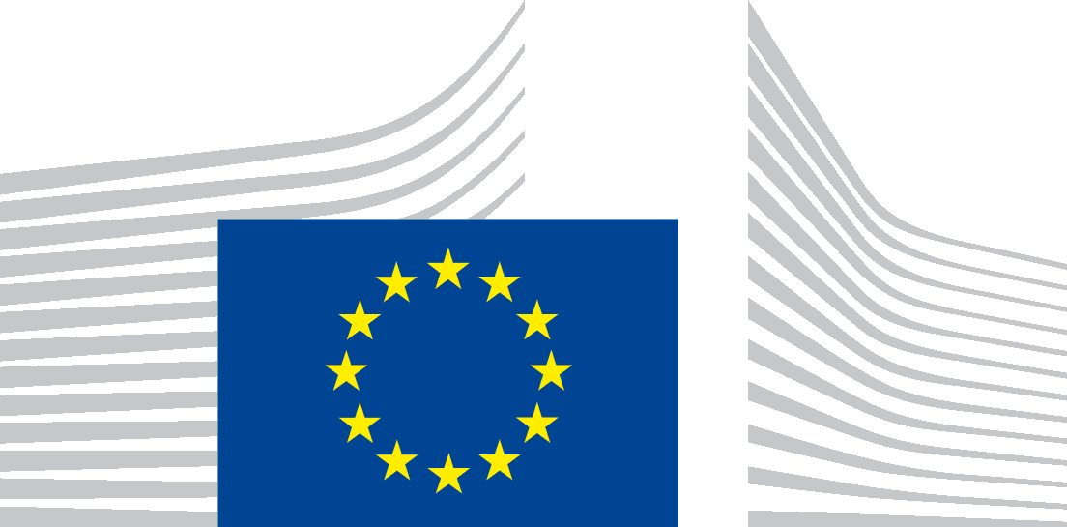 | EUROPEAN COMMISSION  DIRECTORATE-GENERAL  REGIONAL AND URBAN POLICY  Policy  Financial Instruments and International Financial Institutions Relations
Information session

Call for proposals <2015CE16BGT001>

Multi-region assistance for the assessment of the potential use of financial instruments supported by the ERDF, CF, ESF and EAFRD in accordance with Title IV of Regulation (EU) 1303/2013

26 May 2015 – 13:00 – 17:30 - Brussels

Venue: Hotel Silken Berlaymont
Boulevard Charlemagne 11-19, Brussels, 1000, Belgium

Draft AGENDA

12:30 | Registration & Welcome coffee
13:00 | The objectives and the themes of the call  Presentation by the Commission  Questions & Answers
14:00  15:00  15:20 | Eligibility, selection and award criteria  Presentation by the Commission  Questions & Answers  Coffee break  Financial provisions and grant agreement  Presentation by the Commission  Questions & Answers
16:20 | Timetable and practical information  Presentation by the Commission  Questions & Answers
17:30 | Closure of the meeting

The first Call for proposals on the Multi-region assistance for the assessment of the potential use of financial instruments supported by the ERDF, CF, ESF and EAFRD in accordance with Title IV of Regulation (EU) 1303/2013 was launched on 28 April 2015: http://ec.europa.eu/regional_policy/en/newsroom/funding-opportunities/calls-for-proposal/.

In order to inform potential beneficiaries and stimulate their application, an information session will be held in Brussels on 26 May 2015, afternoon, organised by the European Commission, in particular DG REGIO, DG AGRI and DG EMPL.

The information session is open only to eligible applicants, i.e. managing authorities/implementing bodies as defined in point 6.1 of the call for proposals, as well as financial institutions that are interested in participating in the grant actions.

During the information session the Commission will briefly present the main elements of the call and reply to questions asked by participants.

The recordings of the information session, as well as a list of questions raised and answers given during the session, will be made available on the above website.

In addition, any specific questions related to the call may be addressed to: REGIO-MULTI-REGION-CALL@ec.europa.eu, see point 11 of the call for proposal.

The registration is open until 22 May.

The maximum capacity is 100 places, therefore en early registration is recommended.

